**Jenkins Task-2**

**Task Description:**

Create a simple script file and push it to repo. Create a project in Jenkins connected to your GitHub repository. When a commit is made to your repo, automatically build must get triggered from Jenkins and the output must be shared to me via email.

**Steps:**

**1.Create a simple script file and push it to repo:**

Create a simple bash file *(task_2.sh)* and add the simple script in that file, make the file into executable format by (*chmod +x task_2.sh).*

Then do staging and commit the file then push into git repo.

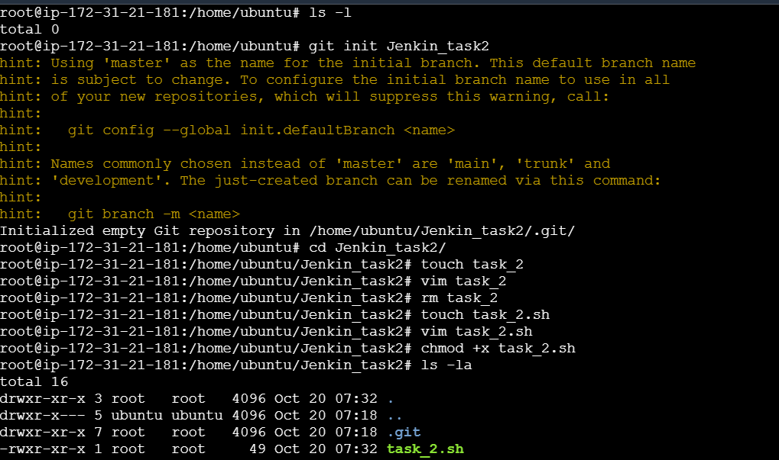

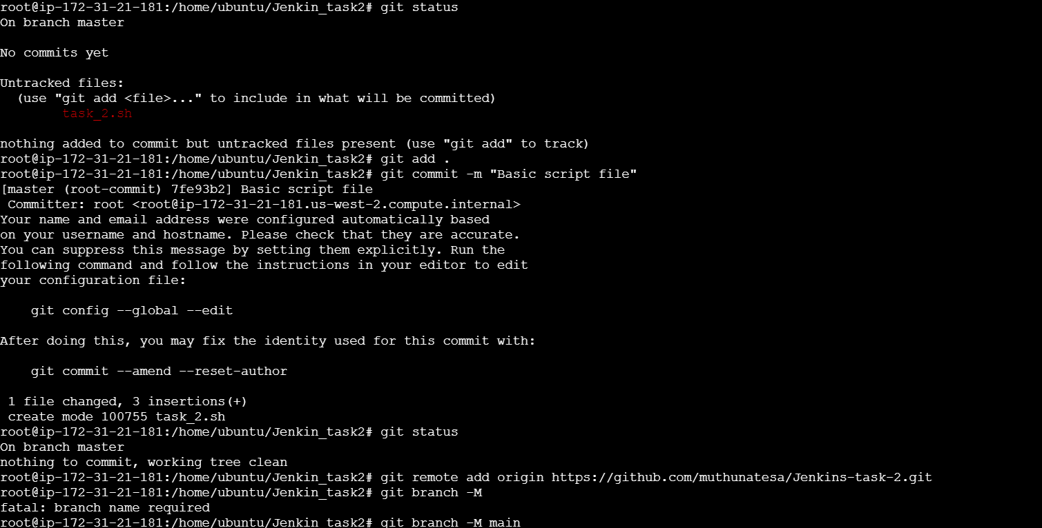

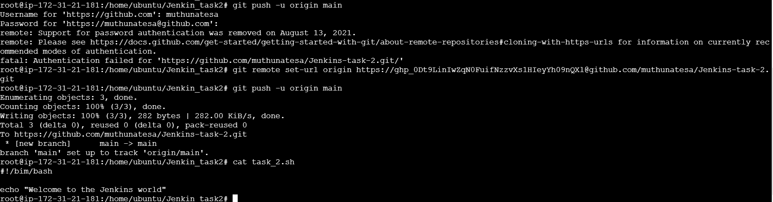

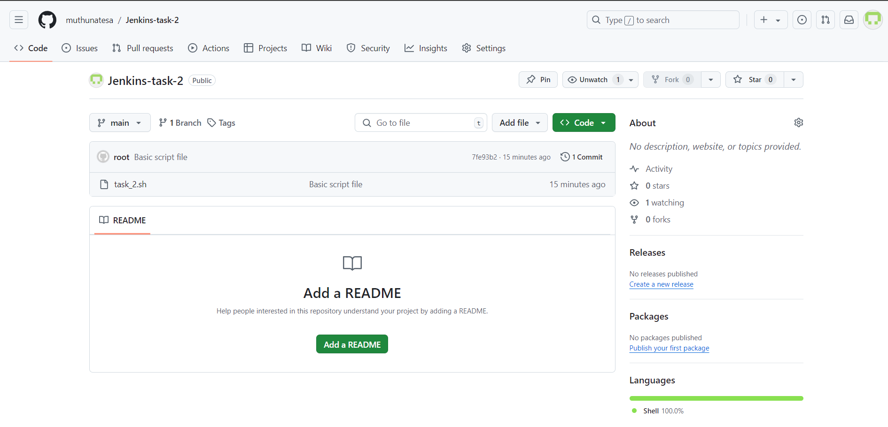

**2.Create a project in Jenkins connected to your GitHub repository**

Create a Pipeline project with SCM as Git and add the GitHub repository and enable the GitHub hook trigger for GITScm polling as Build Trigger to automatically trigger Build whenever code changes are pushed on the GitHub repository, This is achieved by configuring a webhook on the GitHub repository, which notifies Jenkins of any changes made to a code.

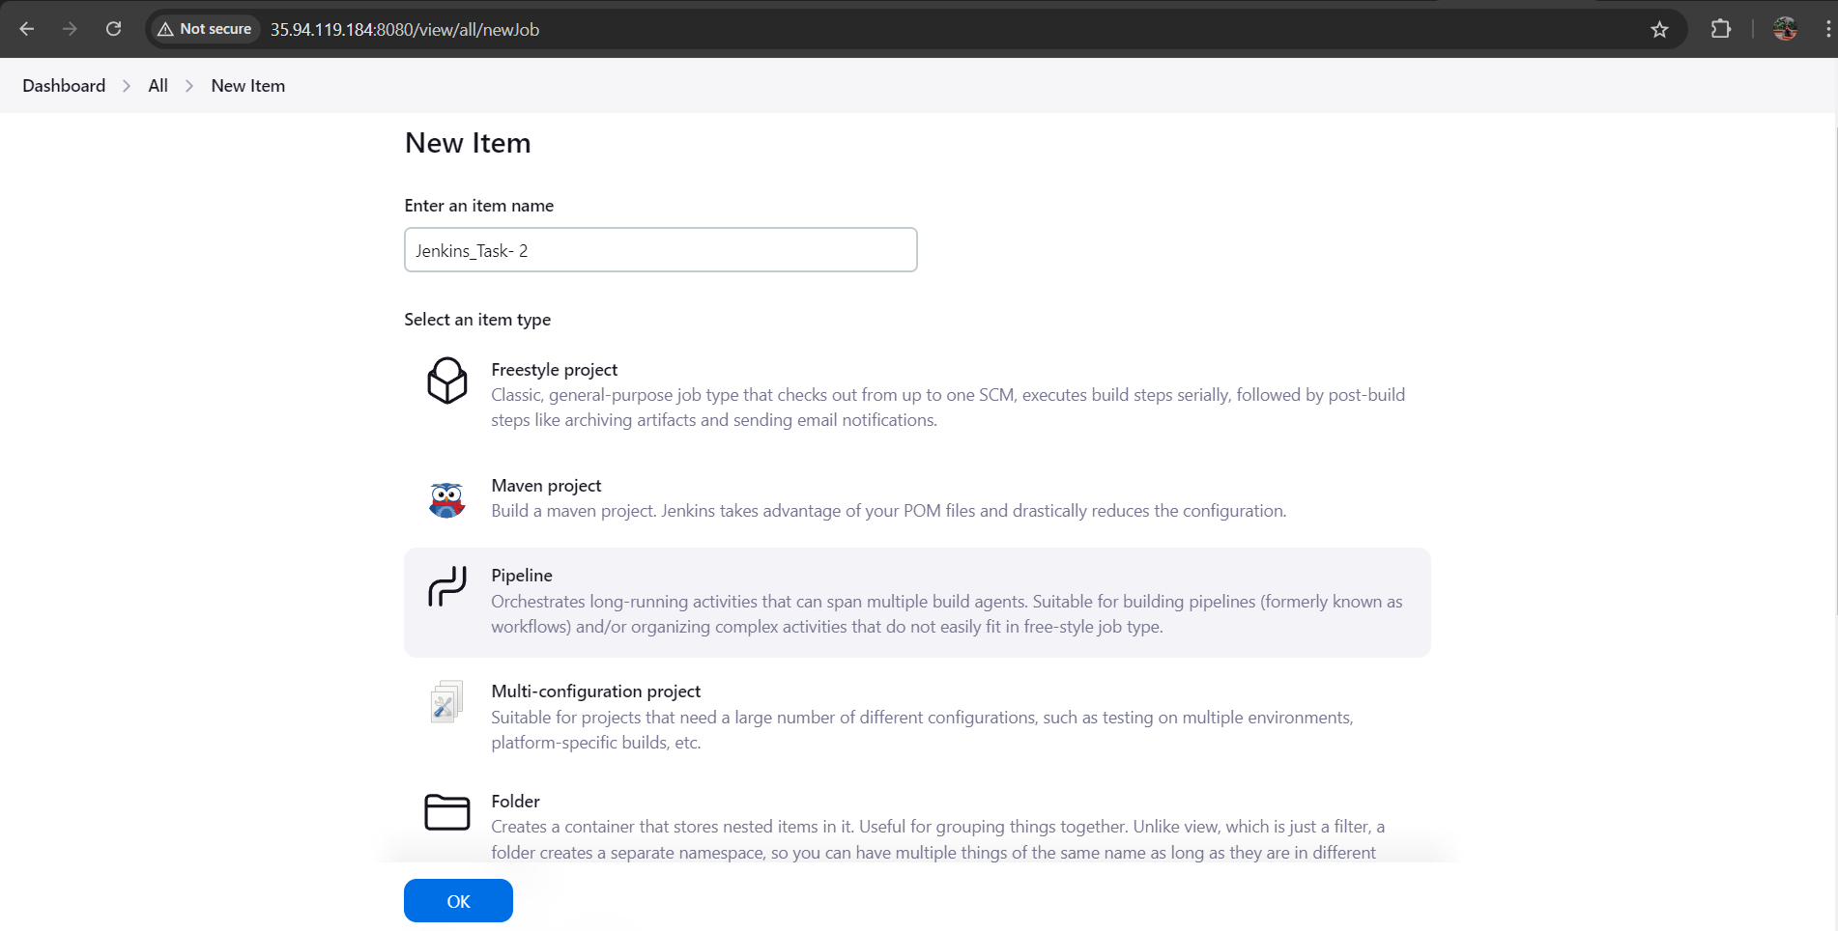

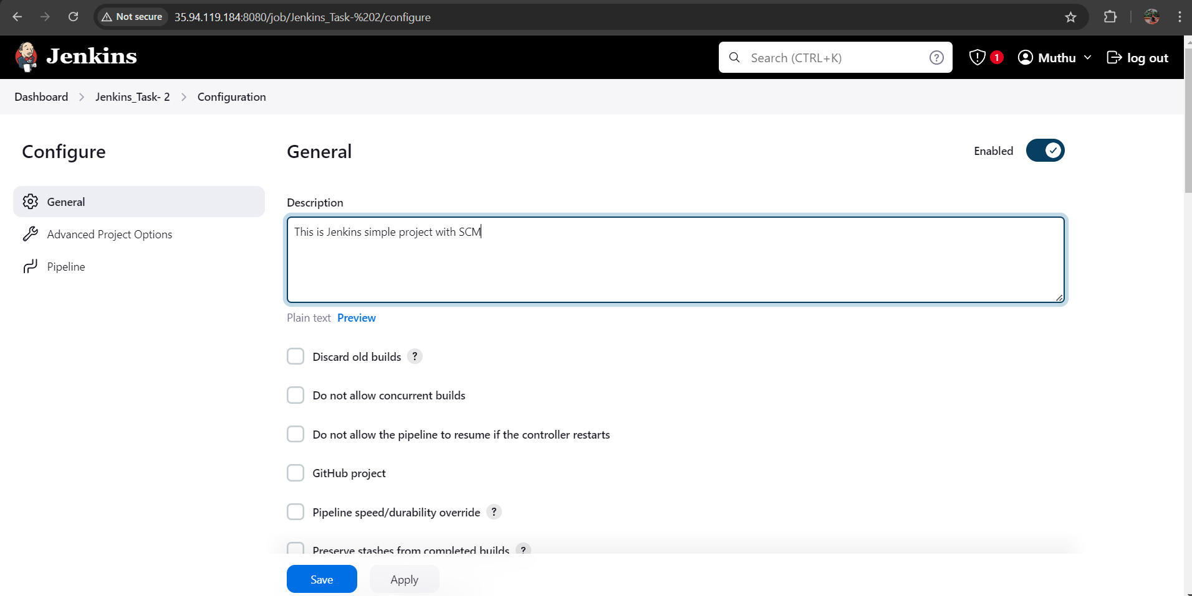

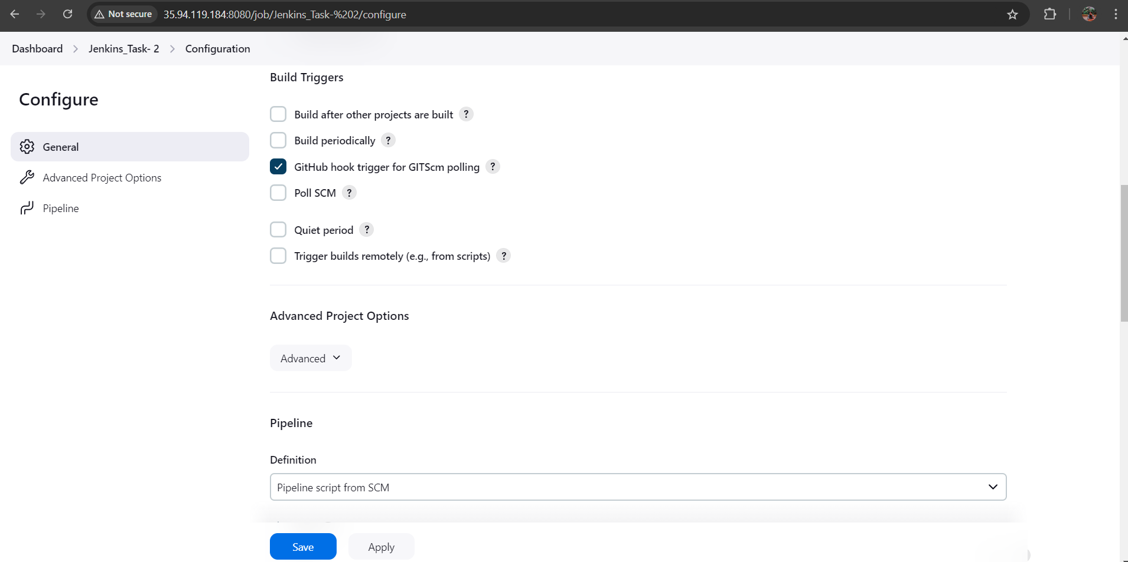

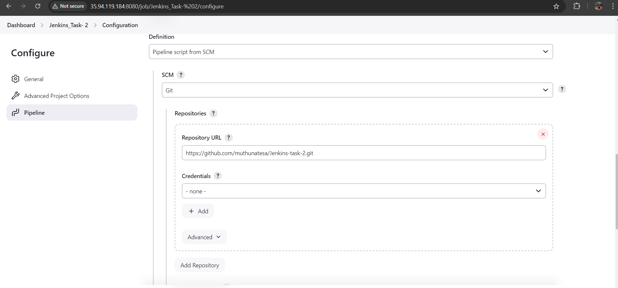

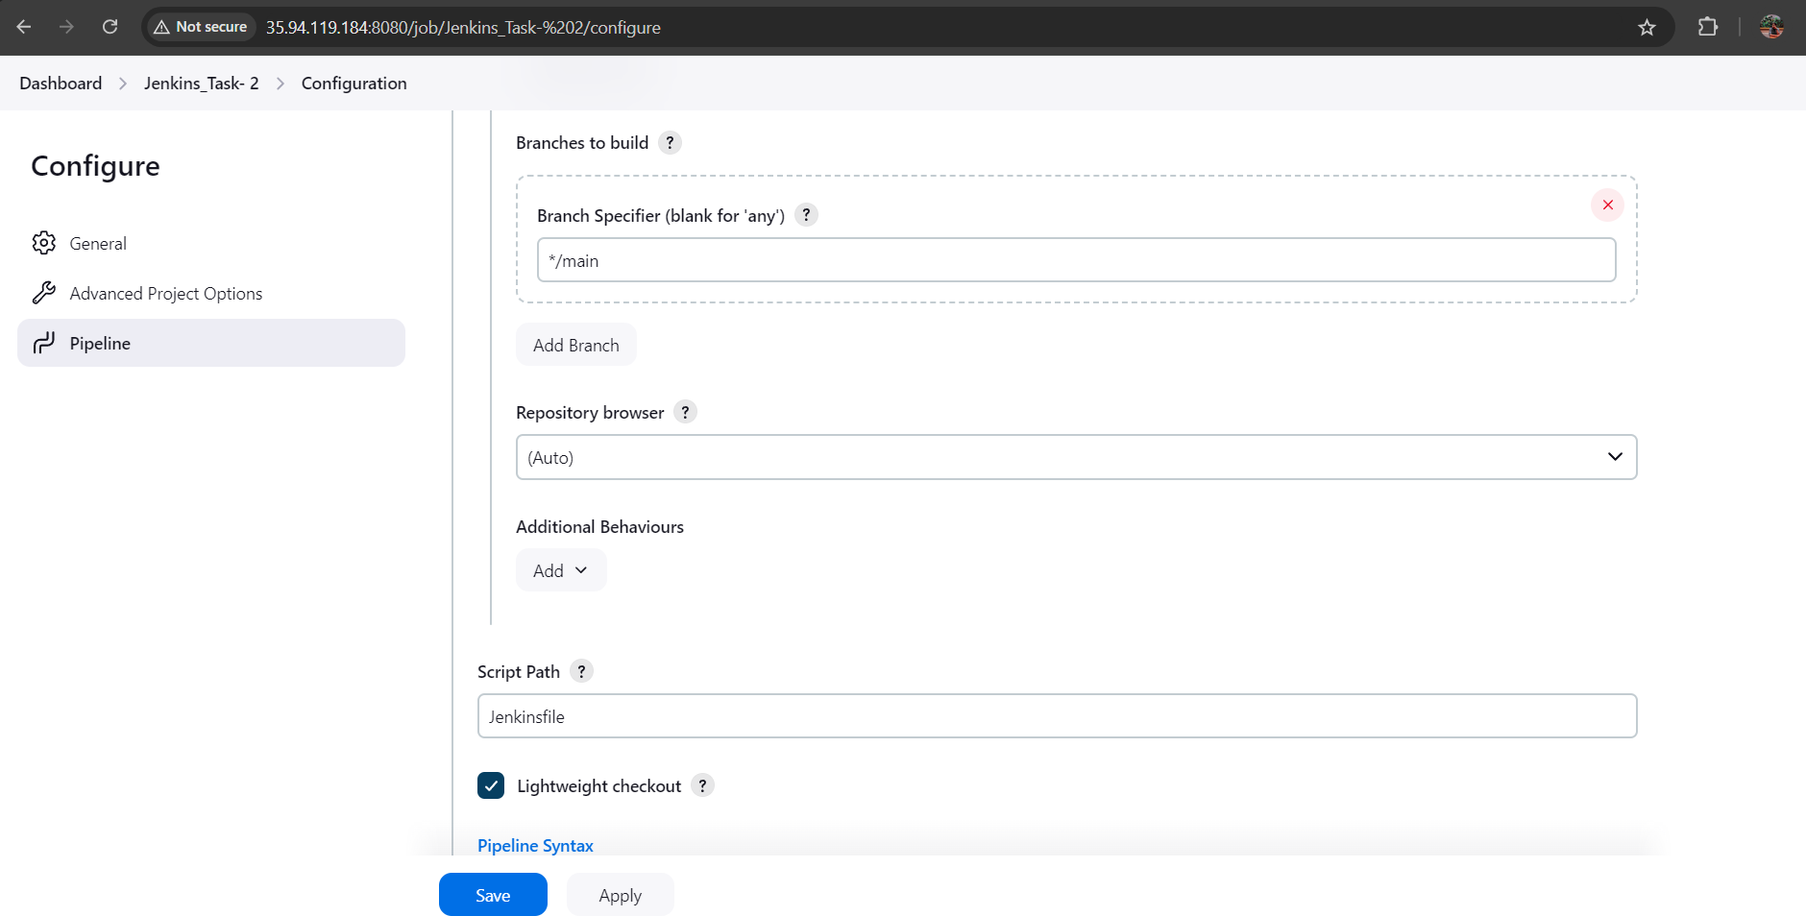

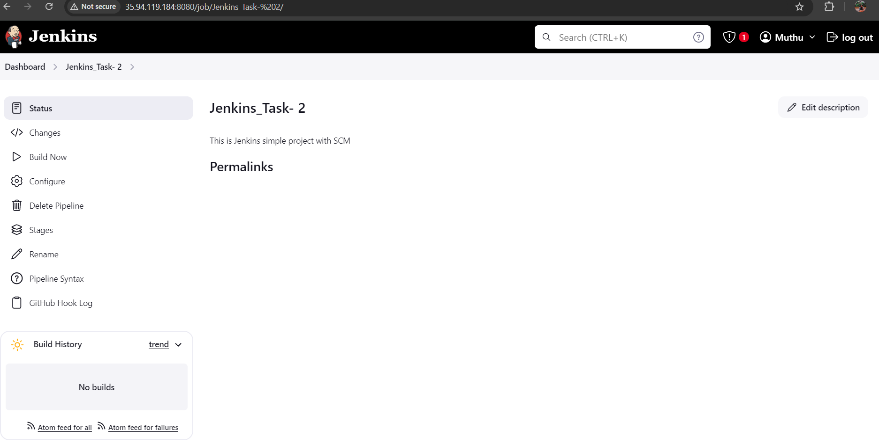

**3.Jenkinsfile**

Create the Jenkinsfile in the same repository and write a declarative pipeline to build the code. It is used to automate the Build and deployment process in Jenkins. After creating the Jenkinsfile push into GitHub.

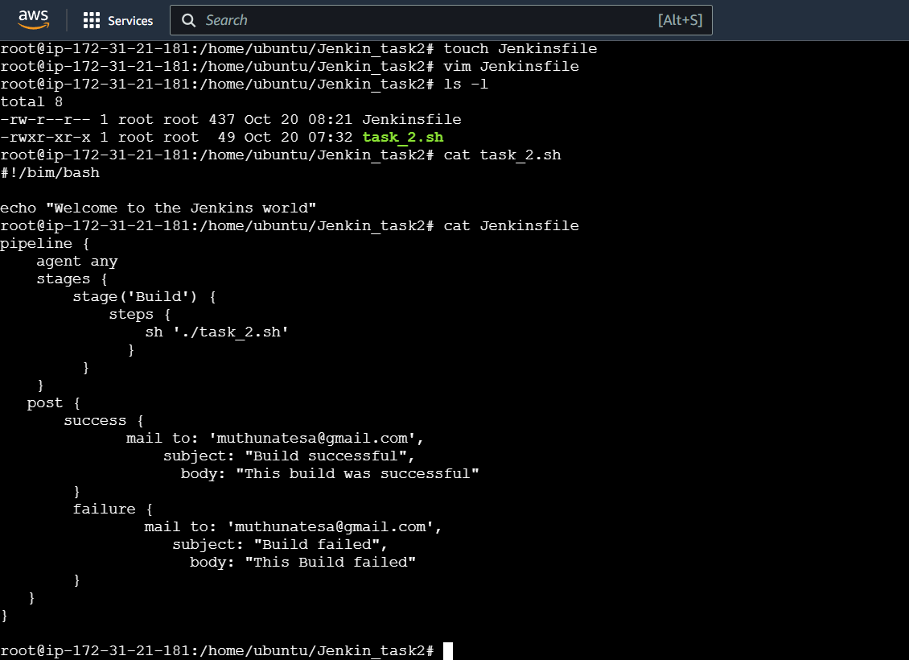

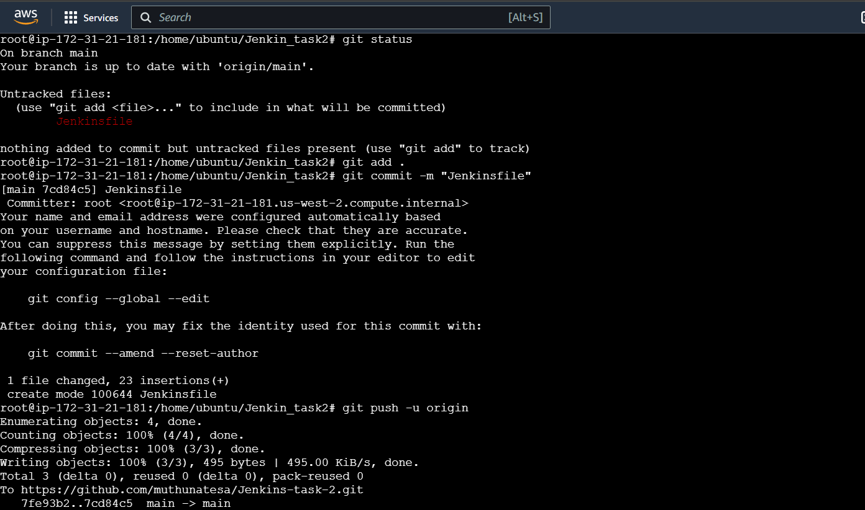

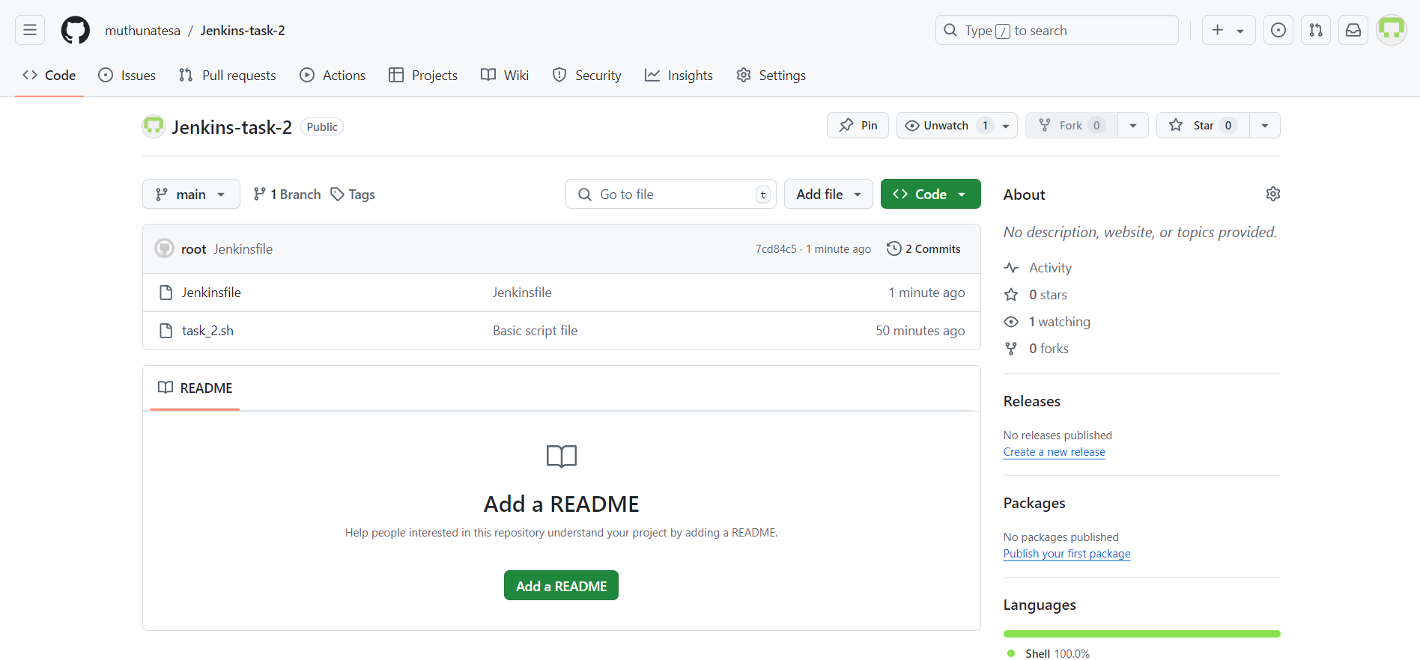

**4.Webhook configuration:**

In the GitHub repository, a webhook is configured with the Jenkins URL *(http://<Jenkins URL>/github-webhook/)* as the payload URL.This webhook is configured to trigger on push events.

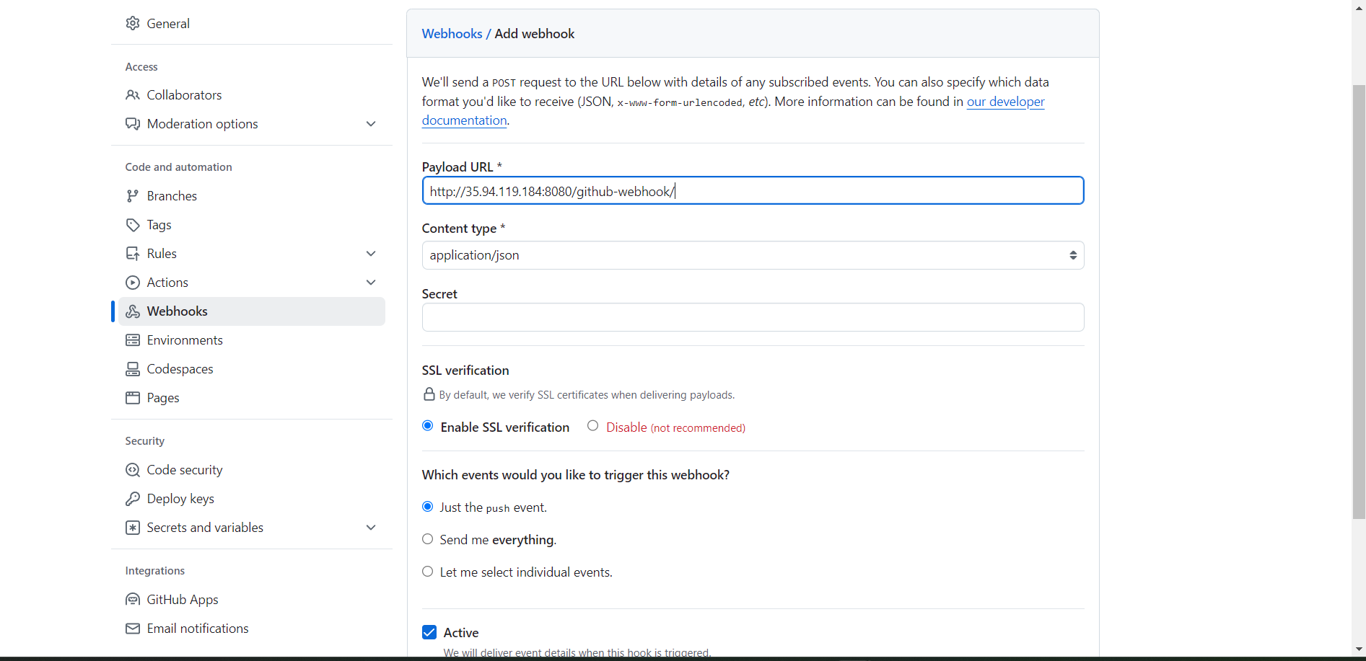

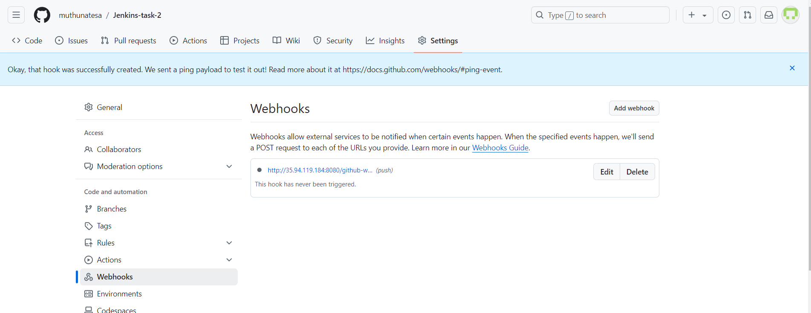

**5.Testing Automatic Build:**

Make some changes or add another script line into the file and commit the changes and push it to GitHub repo.

Now check the Jenkins Build status and console output to whether the Build is successful or failed.

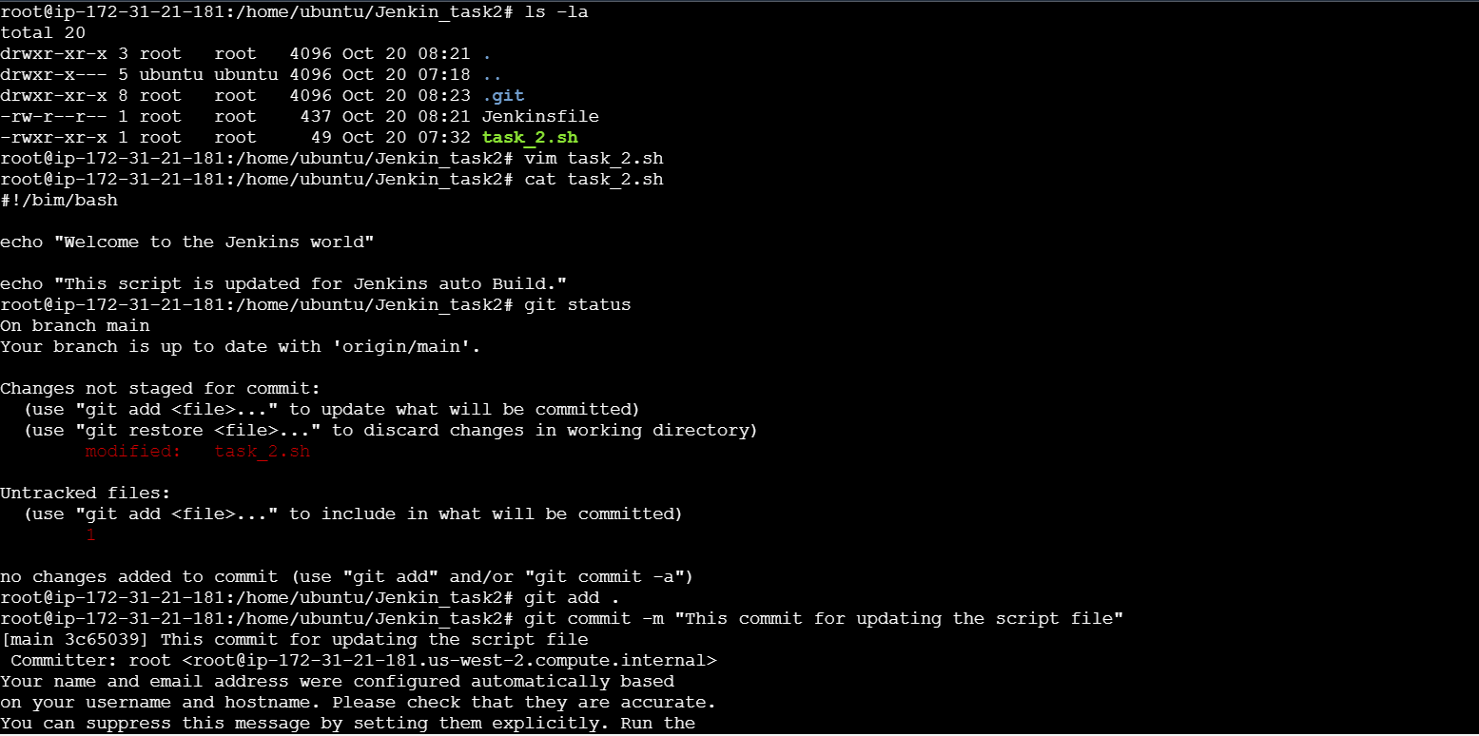

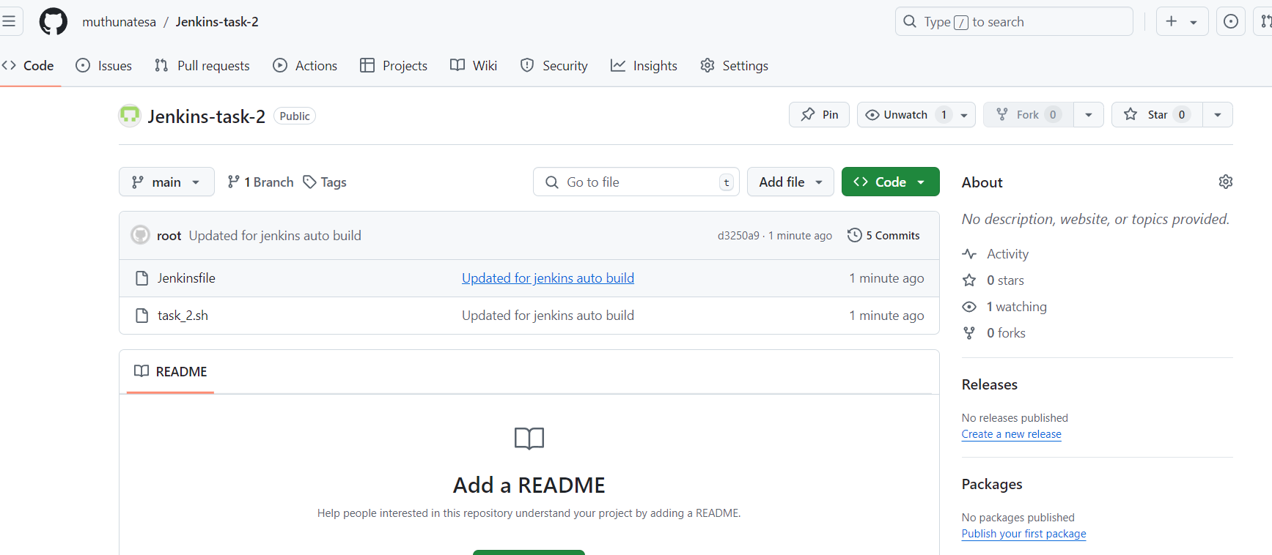

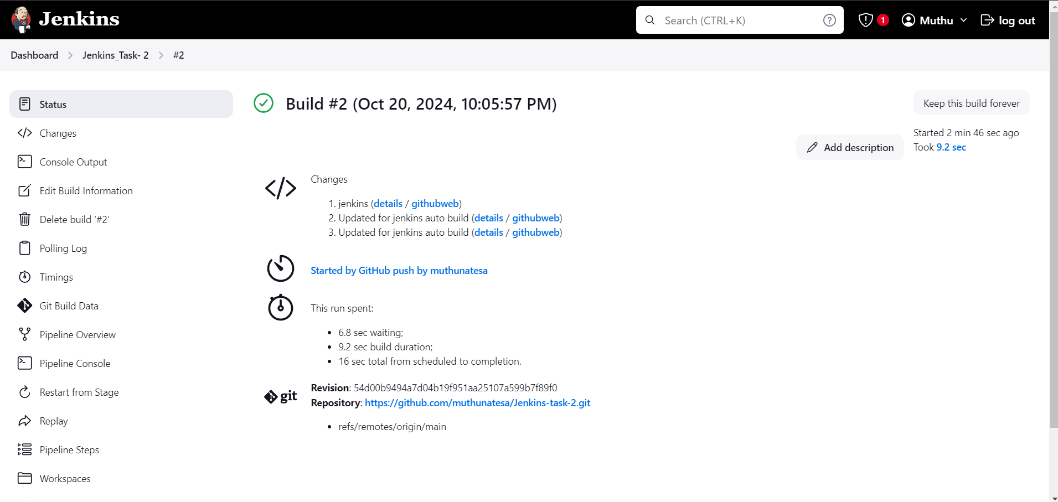

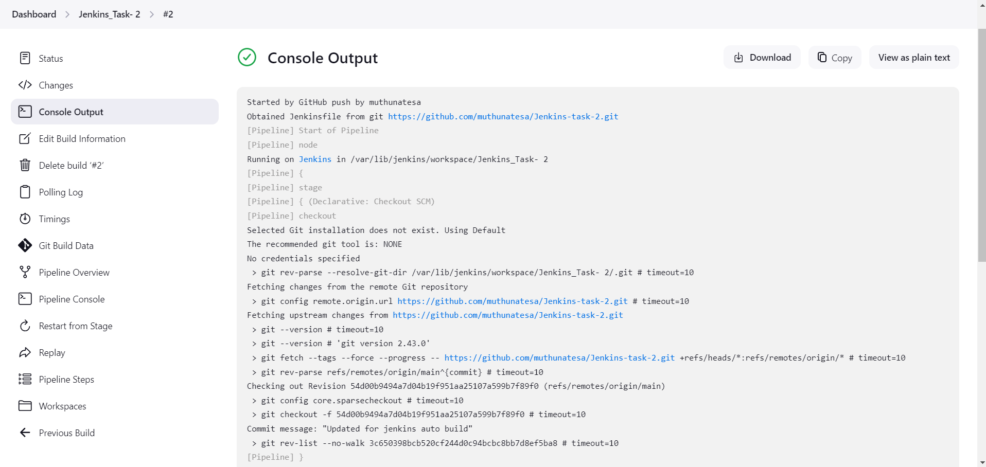

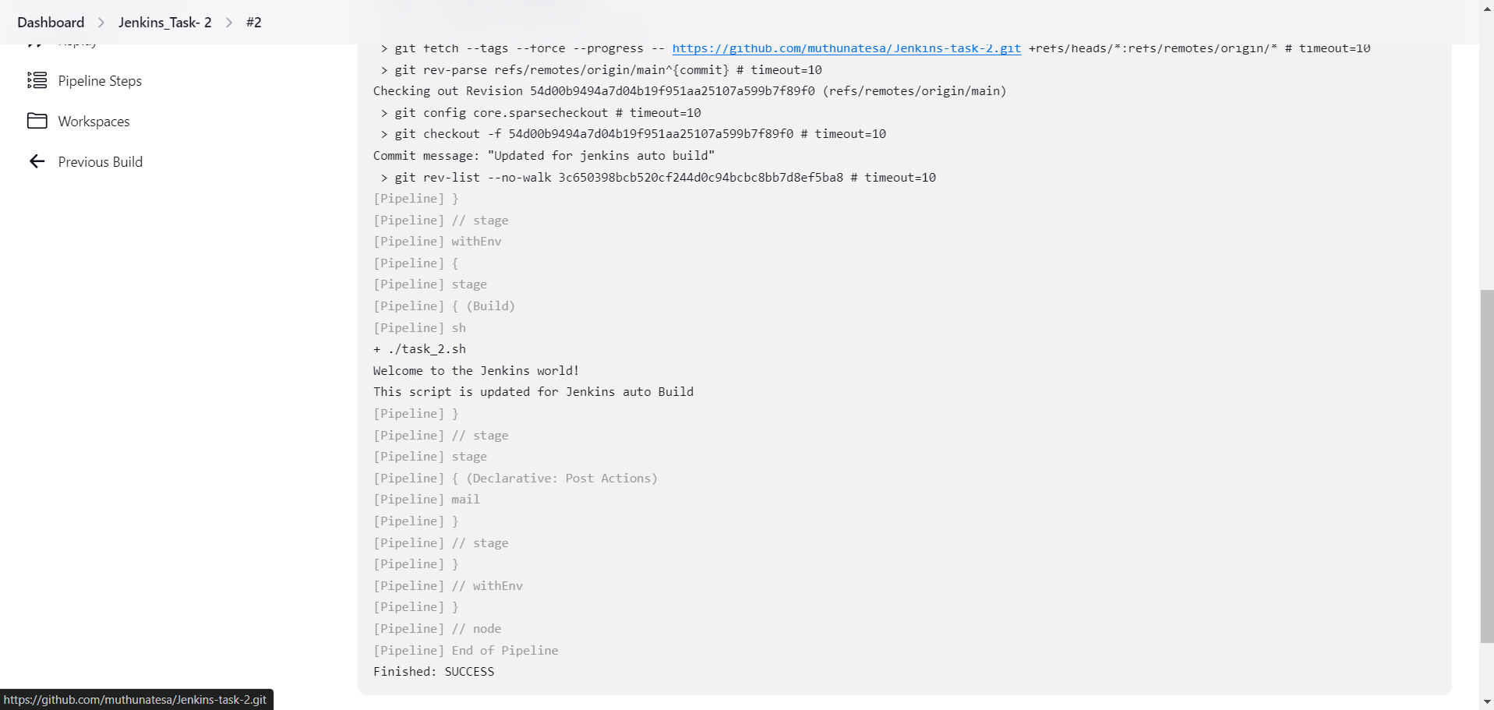

**6.Email Notification:**

Configure the Email notification in Jenkins by going to Manage Jenkins > System configuration and do the SMTP configuration by adding username and password.

Meantime add the Email settings in the Jenkinsfile to get notification via email after the post build process whether the build is successful or failed.

